**May**

13

**ITT, Dublin 24**

3rd Year Project - eUp

Shane Murphy & Maciej Macierzynski

3rd Year Project by Shane Murphy X00085315 and Maciej Macierzynski X0000000 as presented to the Institute of Technology, Tallaght 5th May 2013. The project attempts to provide a solution to traditional paper-based sign up processes still common in many organisations. The main focus of the project is to provide a simple and intuitive way to electronically capture data for use in mailing lists or similar. This core functionality has also been expanded somewhat throughout the development process.

08

**Fall**

Table of Contents

Project Proposal 7

Introduction 7

Project Group 7

Proposal Overview 7

Statement of Problem 8

Objectives 8

Technical Approach 8

Project Management 8

Research 8

Area/Scope Aims 8

Medical Applications 9

Financial Benefits 9

Paperless Hospital 9

Similar Systems 10

ChimpaDeeDoo 10

SignAppNow 10

SignUpSheet 10

Vitro 10

Considered Implementation Technologies 10

ASP.Net 10

JqueryMobile 11

HTML 5 11

Android SDK 11

Captive Portals 11

Data interchange formats 12

Azure 12

Subversion 12

Git 12

Mercurial 12

System Arcitechture 12

Hardware/Software Requirements 14

Proof of concept 14

Exploration and Requirements 14

Project Overview 14

Target Audient 15

Technical Approach 15

ASP.NET 15

Java 15

Azure 16

HTML5/CSS 16

JavaScript/JQueryMobile 16

XML 16

CSV 16

Entity Framework 16

SQL 17

User Stories 17

Release Plan 21

Iteration 1 23

Application Architecture Definition 23

MVC 23

Revised User Stories 23

Implemented User Stories 28

Story ID: 1 – Log In 28

Story ID: 2 – Generate Forms 28

Story ID: 3 28

Story ID: 6 – Account Creation 28

Class Diagram 29

Database Schema 30

Revised Release Plan 32

Difficulties and Learning Outcomes 33

Story ID: 1 – Log In 33

Story ID: 2 – Generate Forms 33

Story ID: 6 – Account Creation 34

Iteration 2 34

Revised User Stories 34

Implemented User Stories 41

Story ID: 4 - Table Exports 41

Story ID: 8 - Mobile Forms 41

Story ID: 7 – Public URLs 41

Story ID: 14 - Error Logging 41

Related Progress 42

Mobile Site 42

Hidden Options 42

CSS 42

Class Diagram 43

Database Schema 44

Revised Release Plan 46

Difficulties and Learning Outcomes 47

Story ID: 4 - Table Exports 47

Story ID: 8 - Mobile Forms 47

Validation 47

Story ID: 7 – Public URLs 47

State diagram 48

Interaction diagram 49

Iteration 3 50

Implemented User Stories 50

Story ID: 11 - OAuth 50

Story ID: 12 – Configure LAN Server 50

Related Progress 50

CSS 50

Mobile Access / View Switcher 51

Class Diagram 51

Database Schema 53

Entity Framework 53

SMO Database 54

Release Plan 55

Difficulties and Learning Outcomes 56

Story ID: 11 - OAuth 56

CSS 56

Mobile View / View Switcher 56

State diagram 56

Interaction diagram 57

Iteration 5 58

Implemented User Stories 58

Story ID: 9 - Statistics 58

Related Progress 59

Payment 59

CSS 59

Mobile Views 59

Class Diagram 59

Database Schema 61

Entity Framework 61

SMO Database 62

Release Plan 63

Difficulties and Learning Outcomes 64

Story ID: 10 - Payment 64

Admin Access 64

Azure Access 64

State diagram 64

Interaction diagram 65

Iteration 6 65

Implemented User Stories 65

Story ID: 13 - Configure WAN Server (Azure) 65

Related Progress 66

Public URLs 66

CSS 66

Mobile Views 66

Release Plan 68

Difficulties and Learning Outcomes 68

Story ID: 9 - Statistics 68

Azure Access 69

# Project Proposal

## Introduction

This document will show the selected group which will work together to develop the year three project. There will have a brief overview of the desired project. This will describe how the project fufills the necessary criteria set out in the project guidelines. The main idea of the application to be designed will be described as well as what platform it will be developed for. There will also be a list of potiential features which could be included in the application.

## Project Group

The following students will be involved in the research, design, and development of the third year­ project:­

Maciej Macierzynski - X00086366

Shane Murphy - X00085315

## Proposal Overview

The aim of this application is to provide an alternative solution to traditional pen and paper sign-up solutions. A common complaint with these traditional approaches are illegible names and phone numbers in the registree’s handwriting, generally form processing can be unreliable for a variety of reasons. Eliminating the hand written aspect of forms has the potential to cut out the form processing and circumventing the illegible handwriting issue.

Security can pose a potential problem with pen and paper forms also. If bank or credit card details are required (e.g. ‘Chugger’ signups for Charities), there is a danger of details being stolen from the representatives folder. If these were stored in an encrypted local or remote database, this would provide a more secure experience for both the donator and the charity representative.

We see such an application being useful in a wide range of varied environments, including college society signups, conventions, street marketing and employment fares. The application will provide an intuitive simple and customisable mobile interface to present to the signatories on a mobile device such as a smart phone, tablet, slate or other.

## Statement of Problem

Traditional pen and paper approaches are sometimes difficult to decifer and require the data to be processed using form processing applications or manually entered into a system later. This is a needless overhead in a technologically literate society, many of whom are already familiar with touch screen technology via smart phones and tablets.

## Objectives

The objective is to provide an elegant solution to this widely unexplored problem. A user interface which can be customised based on the clients required questions, Client branding options and local and remote database storage. The created database will be accessible both from the device and from a full website with secre authentication.

These applications will be built for Android devices as hardware costs are lesser on these devices when compared with iOS and Windows 8 devices.

Exports to the local devices would be provided for where available on the device and also in the form of a .CSV files.

## Technical Approach

The application will be developed using JQueryMobile for using natively on android devices. The database will be implemented with using WebServices ASP.NET and oracle. XML may prove to be an option here which will be researched and conclusions presented in a separate research document.

## Project Management

We will use git and github repositories to coordinate our project development.

# Research

## Area/Scope Aims

Manual form processing involves a tedious amount of human effort put in. The data keyed in by the user may result in typos, and many hours of labor result from this lengthy process.

Automated form processing reduces a number of issues associated with manual processing. They may employ a number of technologies to extract the information including optical character recognition (OCR) for machine print, optical mark reading (OMR) for check/mark sense boxes, bar code recognition (BCR) for barcodes, and intelligent character recognition (ICR) for hand print.

Automated form processing usually involves the following steps.

1. A batch of completed forms is scanned using a high-speed scanner
2. Images are cleaned with document image processing algorithms to improve accuracy
3. Forms are classified based on original template forms and the fields are extracted using the appropriate recognition components
4. Fields which the system flagged with a low confidence are queued for verification by a human operator
5. Verified data is saved into a database or exported to searchable text format such as CSV, XML or PDF

Prerequisites and limitations of automated form processing

1. Scan format: It includes the format of scanned file, Resolution and DPI, Color Mode
2. Configuration: The scanned image layout needs to be configured for this automation
3. Recognition: The pre defined out put formats
4. Result /analyze: Any specific format of result of capture value data presentation.

Nearly 70 percent of organizations acknowledge the increasing importance of mobile technologies, yet only 24 percent have any mobile-enabled processes and 30 percent are still completely reliant on paper. (AIIM, 2012)

## Medical Applications

### Financial Benefits

In the United States roughly $400 billion is spent on paperwork and administrative costs. $12 billion is wasted on communication inneficiencies. (Medical Transcription)In California alone, paperwork accounts for 21% of health costs with $26 billion in administration costs. (Colliver) This is a important issue in the United States with President Obama offering $27 billion to encourage all physicians to switch to computerized medical records by 2015 as part of his 2009 stimulus package. (Chew, 2011)

### Paperless Hospital

According to Slainte Healthcare, Electronic forms are of value to Nurses, Physicians, and Patients – the benefits are measurable for Medical Directors and the Hospital’s Executive Management. Forms can be completed in a third of the time they used to take, saving 66% on staff administration time, increasing the time available to direct patient care by over 10,000 hours annually in a typical facility. Additional benefits such as the increased accuracy, reduced duplication and reduced paper costs mean that the hospital benefits from direct and measurable financial savings.

Reducing paper workin hospitals can impact positively on patient satisfaction, reduce task duplication, prevent administrative errors, improve compliance and reduce costs. (SlainteHealthCare)

## Similar Systems

### ChimpaDeeDoo

Case Study : Schecter guitars adopted app to allow users to enter competition on 32 date Uproar Festival Tour.

Chimpadeedoo is a sign up app solution by MailChimp used to tie into their automated email solution service. It encorporates local storage on the device for offline use, a customisable design interface for branding purposes, ability to use hidden fields with default values, Password protection within the app to stop users accessing settings in the app while signing up and the option to send customised welcome emails to new sign ups. (MailChimp)

### SignAppNow

Simple Web based solution featuring unique URL links to access the signup sheets. Sign up data is available to download via an excel spreadsheet after the signup period expires.

This solution features editable sheets, custom URLs, Private sheets, custom sgn up fields, custom sign up groups and download sheets. (SignAppNow)

### SignUpSheet

Sign Up Sheet is a very basic form app which centres on time based forms for scheduling appointments. Its main features are the ability to send E-mail receipts and built in templates for different types of appointments, interviews etc. (MTM Recognition)

### Vitro

Vitro is a full featured application developed by Slainte Healthcare aimed at the medical industry and hospitals in particular. It has a wide scope but integral to its operation is the use of electronic forms , e-signatures and centrally accessible databases. This application aims to integrate all aspects of medical record keeping and permission acquisition by allowing for the electronic discharging patients, managing their charts and filling in drug prescription forms within a hospital with a complete audit trail. (SlainteHealthCare)

## Considered Implementation Technologies

### ASP.Net

The ASP.NET MVC platform has been chosen to provide the HTML view of the full browser web page, user authentication and to provide backend integration with the server and database. This language is one of our required Microsoft technologies as part of our entry into Microsoft’s Imagine Cup competition.

Some of the benefits of ASP.NET over other posible solutions such as PHP include a higher level of abstraction, allowing easier development in a short time period. (Microsoft) Operating in a more familiar OOP development enviroment will lead to increased productivity and a smaller learning curve. ASP.NET is also fully integrateable with Microsofts Azure service, whereas with other programming languages the Azure SDK does not include a full set of Azure APIs at present leading to more complex code when it comes to integrating. (Parker, 2011)

### JqueryMobile

jQuery Mobile integrates HTML5, CSS3, jQuery and jQuery UI into a touch-optimized, cross platform mobile framework. It is designed to enhance development and to support a wide range of mobile platforms. Ajax support will prove invaluable to the project. For these reasons we have decided to use jQuery Mobile in combination with an Android SDK for developing a hybrid version of the application. (JQuery)

### HTML 5

HTML 5 technologies will be used in both the full browser implementation of the site and in combination with other technologies to develop the front end of the mobile application. HTML5 was developed to provide fleibility and allow more to be accomplished with stand alone HTML. Some of the major benefits associated with HTML is the addition of the canvas and video tag aswell as support for geolocation, client side local stoarage/database, offline cache and support for basic threading. (W3Schools)

### Android SDK

The app is to be developed using the Java programming language with the Android SDK as a native android app for use with both tablets and smartphones. (Android) Android development is supported cross platform between Mac OS X, Windows and Linux Operating systems through the Eclipse IDE which accomodates both members of the programming teams home operating systems. (Android)

### Captive Portals

Using tethering on the hub device would allow users to remotely connect and fill in forms remotely on their own device. This would allow multiple users to fill in a form simultaeneously saving time in crowded environments. This could be achieved by using a captive portal hosted on the hub device. (md_5, 2012)

#### Jetty

Jetty is a small server developed as part of the Eclipse Foundation that can be embedded in a Java program as an object, adding a HTTP module to the application rather than adding the application to a HTTP server. This is alternative option to using captive portals, or maybe be used with captive portals. (Eclipse Foundation)

#### NanoHttpD

NanoHttpD is a small lightweight Server which can be embedded in Java applications. It is a basic server supplying only basic required server features without additional features such as servlet support, config files, logging or administration support. (NanoHTTPD)

### Data interchange formats

XML and JSON will be the main data formats used for communication between mobile device’s and the server. Due to limitations of mobile devices, a vast amount of apps have to transmit large amount of data over the Internet in order to deliver full functionality to the user. XML and JSON are the most common data exchange formats today and they both offer flexible and capable approaches to this problem. (IBM)

### Azure

Windows Azure is a cloud computing solution developed by Microsoft. This platform provides us with many benefits including the following:

Websites can be deployed using ASP.NET using Git or FTP, SQL Database, an API built on REST, HTML and XML, Azure integrates well with Git and Eclipse. (Microsoft)

### Subversion

Subversion (SVN) provides a single repository that all users must pull and push/commit to. All changes are slaves to the master repository and all changes are available to everyone with access to the repository immediately after saving. (Apache)

### Git

Git is a distributed version control software which allows local repositories to be branched from the master repository, meaning users have a number of repositories at any one time. (Git)

### Mercurial

Mercurial is quite similar to git in features. Like Git, Mercurial is a distributed version control software allowing local repositories to be branched from the master repository, meaning users have a number of repositories at any one time. (Mercurial)

When it came to a choice between Mercurial and git, the deciding factor came down to the culture and support community which operates areound the Git SVC.

## System Arcitechture

The applications backend will be implemented using the ASP.NET framework using an MVC architecture which separates a system into three components:

- Model – The system's data, often stored and retrieved from a database.

- View – The component that provides the UI, typically created from the model.

- Controller – This handles user interaction.

Dividing an application into separate parts makes it easier to manage and understand its complexity. Testability is also improved by separation of business logic, input logic and UI logic. Any unit testing framework compatible with .NET can be used to speed up testing process. (Microsoft)

Implementing an URL mapping feature allows for searchable and comprehensible URLs that work with representational state transfer (REST) addressing patterns and search engine optimization (SEO). (IBM)

REST is an architectural style we have decided to use in the client - server interactions. It focuses on resource states, addressing, transferring over HTTP and defines a set of principles to design a RESTfull web service as follows

1.Use HTTP methods in an explicit manner

* POST to create a new resource
* GET to retrieve a resource
* PUT to change/update a resource
* DELETE to remove/delete a resource

2. Be stateless

No session state is allowed on a server. All data required by a server to generate a response such as parameters must be included within the body and header of a HTTP request.

3. Expose directory structure-like URIs

URIs should be self-descriptive, intuitive and predictable. To achieve this an URI can be defined as a directory structure with a root and branches (sub-paths). Hiding file extensions, avoiding query strings and substituting spaces with underscores or hyphens is considered a good practice.

4. Transfer XML, JSON or both

Data exchanged between a client and a server should be kept in a simple, human-readable format.

In many cases a RESTful approach offers some benefits over other technologies:

- Caching - Resources retrieved by GET request can be cached in a number of ways.

- Scaling – Stateless approaches such as REST are easier to scale out.

- Interoperability - Does not require any toolkits, only an HTTP library.

For a mobile version of an app we have chosen a hybrid approach as the one that offers cross platform affinity by using web technologies (JavaScript, HTML) rendered by native browser rendering engine (WebKit) and presented in a full screen format.

## Hardware/Software Requirements

Hardware required:

- Tablet/Smartphone running Android OS

Software needed to develop the system is free/open source.

Windows Azure account is free(9 months for Imagine Cup contestants).

## Proof of concept

As part of our Distributed & Mobile Computing (DMC) module we chose to work with a number of technologies which would prove useful in our project.

Our DMC CA2 utilised the Android SDK through Eclipse and used HTML 5, JavaScript, JqueryMobile as implemented within a WebView to create a live map of all running trains in Ireland along with rail line layout and station markers. Other technologies which featured in this project include XML and KML. The source code management tool ‘Git’ was used to manage code as we branched and merged code, proving invaluable in handling conflicts and controlling division of work. We chose GitHub as our Git repository location for this CA to handle Forking, pull and push requests, and will continue using it for the full 3rd year project.

Throughout semester 5 we have been learning C#, Razor Sintaxand MVC technologies in our Web Design and Development module. Using ASP.Net to develop dynamic webpages that integrate and use a backend database.

As we work through the project over the course of the next few months, we will expand our current knowledge in these areas and learn to implement and integrate these technologies.

# Exploration and Requirements

## Project Overview

The project attempts to simplify the sign up and registration process by allowing for an electronic solution to the traditional pen and paper approach still widely used today. Large-scale form processing applications may be impractical for smaller businesses or personal uses. Creating the data in a digital format from the offset eliminates unnecessary data input and simplifies the process for the user. Capturing this data digitally allows demographics and other statistics to be generated quickly and conveniently.

Application integration is an important aspect of this system, as users will invariably wish to process this data with any number of applications for use in mailing lists, etc. .CSV files are supported by a wide variety of applications and as such we feel this is the best format to focus on for export purposes.

The Application encompasses a Web Service built on the ASP.NET platform and Database backend implemented using Entity Framework and SQL Database on Microsoft’s Azure platform and a Client side application and Web App.

## Target Audient

The application can serve a wide range of purposes but is primarily aimed at small to medium businesses, Charity organisations and personal use.

The application would be suitable for use at events such as trade fairs employment fairs, conventions, seminars, and charity functions. Tablets running the application could be installed in stores for customers, allowing businesses to engage customer footfall with the e-commerce side of the business as well. Door-to-door salespersons, street teams or personal users organizing trips, meetings or college society sign ups may also find the application useful.

## Technical Approach

### ASP.NET

The ASP.NET MVC platform has been chosen to provide the HTML view of the full browser web page, user authentication and to provide backend integration with the server and database. This language is one of our required Microsoft technologies as part of our entry into Microsoft’s Imagine Cup competition.

Some of the benefits of ASP.NET over other possible solutions such as PHP include a higher level of abstraction, allowing easier development in a short time period. (Microsoft) Operating in a more familiar OOP development environment will lead to increased productivity and a smaller learning curve. ASP.NET can also be fully integrated with Microsoft’s Azure service, whereas with other programming languages the Azure SDK does not include a full set of Azure APIs at present leading to more complex code when it comes to integrating. (Parker, 2011)

### Java

The app is to be developed using the Java programming language with the Android SDK as a native android app for use with both tablets and smartphones. (Android) Android development is supported cross platform between Mac OS X, Windows and Linux Operating systems through the Eclipse IDE which accommodates both members of the programming teams home operating systems. (Android)

### Azure

Windows Azure is a cloud computing solution developed by Microsoft. This platform provides us with many benefits including the following:

Websites can be deployed using ASP.NET using Git or FTP, SQL Database, an API built on REST, HTML and XML, Azure integrates well with Git and Eclipse. (Microsoft)

### HTML5/CSS

HTML 5 technologies will be used in both the full browser implementation of the site and in combination with other technologies to develop the front end of the mobile application. HTML5 was developed to provide flexibility and allow more to be accomplished with stand alone HTML. Some of the major benefits associated with HTML is the addition of the canvas and video tag as well as support for geolocation, client side local storage/database, offline cache and support for basic threading. (W3Schools)

### JavaScript/JQueryMobile

jQuery Mobile integrates HTML5, CSS3, jQuery and jQuery UI into a touch-optimized, cross platform mobile framework. It is designed to enhance development and to support a wide range of mobile platforms. Ajax support will prove invaluable to the project. For these reasons we have decided to use jQuery Mobile in combination with an Android SDK for developing a hybrid version of the application. (JQuery)

### XML

XML and JSON will be the main data formats used for communication between mobile device’s and the server. Due to limitations of mobile devices, a vast amount of apps have to transmit large amount of data over the Internet in order to deliver full functionality to the user. XML and JSON are the most common data exchange formats today and they both offer flexible and capable approaches to this problem. (IBM)

### CSV

The so-called CSV (Comma Separated Values) format is the most common import and export format for spreadsheets and databases. Surprisingly, while this format is very common, it has never been formally documented. so the format is operationally defined by the many applications which read and write it. (Python.org)

### Entity Framework

Entity Framework (EF) is an object-relational mapper that enables .NET developers to work with relational data using domain-specific objects. It provides a layer of abstraction that allows us to bypass the use of SQL statements to access and modify relational databases.

### SQL

To dynamically create user tables we will use a combination of Entity Framework and SQL. Template tables will be created using Entity Framework to allow users to specify customer columns which will then be committed and stored as an SQL table in the database.

## User Stories

#### Log In

|  |  |  |  |
| --- | --- | --- | --- |
| **ID: 1** | **Story Title: Log In** | **Priority: High** | **Estimate: 2 hours** |
| As a user I want to log in so that I can access my account | | | |

**Confirmation:**

1. **Success** – valid user logged in and referred to personal home page
   1. User Presented with a list of their associated sheets table entries.

Which can be selected to view the individual signatories.

1. **Failure** – display message
   1. Username and hash of password does not match that stored in the database.
   2. Display failed login message, allow retry up to 3 attempts.

#### Generate Registration Form

|  |  |  |  |
| --- | --- | --- | --- |
| **ID: 2** | **Story Title: Generate Registration Form** | **Priority: High** | **Estimate: 5 hours** |
| As a User I want to generate custom registration forms so that I can capture data from clients | | | |

**Confirmation:**

1. **Success** – Valid table names provided, table created, stored and associated with user profile
   1. User returned to list of tables including newly created one.
2. **Failure** – Invalid Input
   1. User enters values disallowed by form validation
      1. Indicated by highlighting invalid field
   2. Failed table creation
      1. Notify user and allow retry

#### Select Input type

|  |  |  |  |
| --- | --- | --- | --- |
| **ID: 3** | **Story Title: Select Input Type** | **Priority: High** | **Estimate: 5 hours** |
| As a User I want to select predetermined input types (radio buttons, checkboxes) for certain custom fields, and be able to specify custom answers. | | | |

**Confirmation:**

1. **Success** – Table created with defined input types and default question layout.
   1. User returned to list of tables including newly created one.
2. **Failure** – Invalid Input
   1. User enters values disallowed by form validation
      1. Indicated by highlighting invalid field
   2. Failed table creation
      1. Notify user and allow retry

#### Table Exports

|  |  |  |  |
| --- | --- | --- | --- |
| **ID: 4** | **Story Title: Table Exports** | **Priority: High** | **Estimate: 5 Hours** |
| As a User I want to export Tables so that I can easily import them to other applications. | | | |

**Confirmation:**

1. **Success** – File downloaded to client machine.
   1. File downloaded to client machine at user defined location
2. **Failure** – Cannot export table.
   1. Table may be being updated by another device (AJAX call)
   2. Table not found

#### Admin Access

|  |  |  |  |
| --- | --- | --- | --- |
| **ID: 5** | **Story Title: Admin access** | **Priority: High** | **Estimate:4 Hours** |
| As a sit administrator I want access users information to build profiles and send emails. | | | |

**Confirmation:**

1. **Success** – View list of usernames, full names, location and email addresses.
   1. View displayed to admin
2. **Failure** –
   1. Detail failures & messages

#### Account Creation

|  |  |  |  |
| --- | --- | --- | --- |
| **ID: 6** | **Story Title: Account Creation** | **Priority: High** | **Estimate: 5 Hours** |
| As a User I want to be able to create new account so that I can log in. | | | |

**Confirmation:**

1. **Success** – User account created
   1. user redirected to log in page
2. **Failure** – Cannot create account, display message
   1. Account already exists
   2. Invalid inputs/password does not match

#### Public URLS

|  |  |  |  |
| --- | --- | --- | --- |
| **ID: 7** | **Story Title: Public URLs** | **Priority: Medium** | **Estimate:** |
| As a User I want to share public links to social networking sites so that clients can complete form remotely. | | | |

**Confirmation:**

1. **Success** – Public URL provided to user
   1. Option to share directly to social networking sites
2. **Failure** – Unable to provide public URL

#### Mobile Forms

|  |  |  |  |
| --- | --- | --- | --- |
| **ID: 8** | **Story Title: Mobile forms** | **Priority: High** | **Estimate:** |
| As a User I want to populate tables from the mobile app so that I can present the form to customers in person | | | |

**Confirmation:**

1. **Success** – User verified and tables associated with user displayed
   1. User selects table to populate
   2. Form presented to screen
2. **Failure** – No Tables to display
   1. User provided with option of creating new table.

# 

## Release Plan

Also Attached.

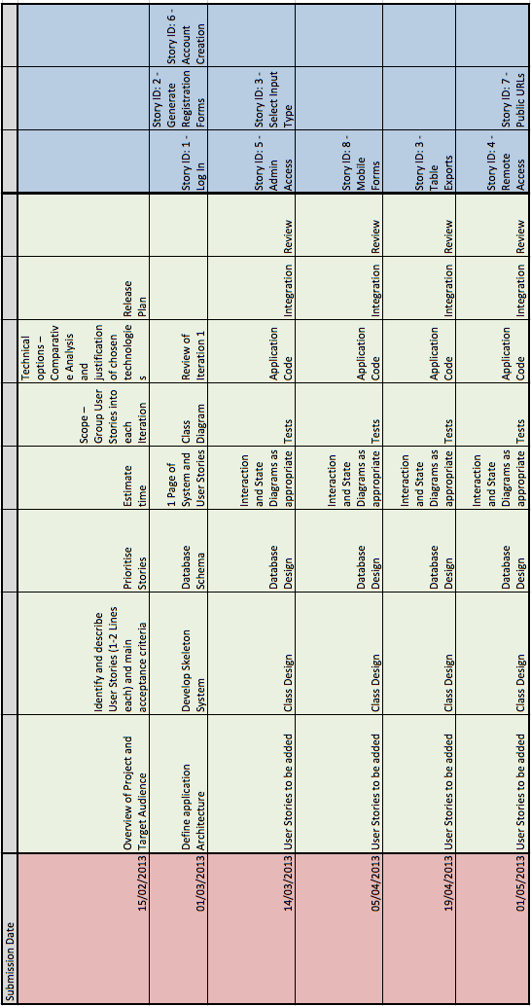

# Iteration 1

## Application Architecture Definition

### MVC

The Model View Controller architecture is being implemented in this project.

MVC is an Object Orientated development methodology to enable code reuse by separating the application into 3 parts: the Model, View and Controller.

The model is charged with managing fundamental behaviours and the data for the application, typically seen implemented as a database. The view is the layer at which the user may interact with the application. It is the user interface and is responsible for rendering data passed to it from the model. The controller handles user input via the view layer and makes calls to model objects.

## Revised User Stories

#### Log In

|  |  |  |  |
| --- | --- | --- | --- |
| **ID: 1** | **Story Title: Log In** | **Priority: High** | **Estimate: 2 hours** |
| As a user I want to log in so that I can access my account | | | |

**Confirmation:**

1. **Success** – valid user logged in and referred to personal home page
   1. User Presented with a list of their associated sheets table entries.

Which can be selected to view the individual signatories.

1. **Failure** – display message
   1. Username and hash of password does not match that stored in the database.
   2. Display failed login message, allow retry up to 3 attempts.

#### Generate Form

|  |  |  |  |
| --- | --- | --- | --- |
| **ID: 2** | **Story Title: Generate Form** | **Priority: High** | **Estimate: 5 hours** |
| As a User I want to generate custom registration forms so that I can capture data from clients | | | |

**Confirmation:**

1. **Success** – Valid table names provided, table created, stored and associated with user profile
   1. User returned to list of tables including newly created one.
2. **Failure** – Invalid Input
   1. User enters values disallowed by form validation
      1. Indicated by highlighting invalid field
   2. Failed table creation
      1. Notify user and allow retry

#### Select Input type

|  |  |  |  |
| --- | --- | --- | --- |
| **ID: 3** | **Story Title: Select Input Type** | **Priority: High** | **Estimate: 5 hours** |
| As a User I want to select predetermined input types (radio buttons, checkboxes) for certain custom fields, and be able to specify custom answers. | | | |

**Confirmation:**

1. **Success** – Table created with defined input types and default question layout.
   1. User returned to list of tables including newly created one.
2. **Failure** – Invalid Input
   1. User enters values disallowed by form validation
      1. Indicated by highlighting invalid field
   2. Failed table creation
      1. Notify user and allow retry

#### Table Exports

|  |  |  |  |
| --- | --- | --- | --- |
| **ID: 4** | **Story Title: Table Exports** | **Priority: High** | **Estimate: 5 Hours** |
| As a User I want to export Tables so that I can easily import them to other applications. | | | |

**Confirmation:**

1. **Success** – File downloaded to client machine.
   1. File downloaded to client machine at user defined location
2. **Failure** – Cannot export table.
   1. Table may be being updated by another device (AJAX call)
   2. Table not found

#### Admin Access

|  |  |  |  |
| --- | --- | --- | --- |
| **ID: 5** | **Story Title: Admin access** | **Priority: High** | **Estimate:4 Hours** |
| As a sit administrator I want access users information to build profiles and send emails. | | | |

**Confirmation:**

1. **Success** – View list of usernames, full names, location and email addresses.
   1. View displayed to admin
2. **Failure** –
   1. Detail failures & messages

#### Account Creation

|  |  |  |  |
| --- | --- | --- | --- |
| **ID: 6** | **Story Title: Account Creation** | **Priority: High** | **Estimate: 5 Hours** |
| As a User I want to be able to create new account so that I can log in. | | | |

**Confirmation:**

1. **Success** – User account created
   1. user redirected personal homepage
2. **Failure** – Cannot create account, display message
   1. Account already exists
   2. Invalid inputs/password does not match

#### Public URLS

|  |  |  |  |
| --- | --- | --- | --- |
| **ID: 7** | **Story Title: Public URLs** | **Priority: Medium** | **Estimate:** |
| As a User I want to share public links to social networking sites so that clients can complete form remotely. | | | |

**Confirmation:**

1. **Success** – Public URL provided to user
   1. Option to share directly to social networking sites
2. **Failure** – Unable to provide public URL

#### Mobile Forms

|  |  |  |  |
| --- | --- | --- | --- |
| **ID: 8** | **Story Title: Mobile forms** | **Priority: High** | **Estimate:** |
| As a User I want to populate tables from the mobile app so that I can present the form to customers in person | | | |

**Confirmation:**

1. **Success** – User verified and tables associated with user displayed
   1. User selects table to populate
   2. Form presented to screen
2. **Failure** – No Tables to display
   1. User provided with option of creating new table.

#### Statistics

|  |  |  |  |
| --- | --- | --- | --- |
| **ID: 9** | **Story Title: Statistics** | **Priority: Medium** | **Estimate: 2 Days** |
| As a User I want to analyse table data so that I can better target and understand my clients and determine target markets | | | |

**Confirmation:**

1. **Success** – Table analytics displayed
   1. User can filter results into categories
2. **Failure** – No Analytics available
   1. Table empty
   2. No data fields in table are capable of having analytics associated with them

#### Payment

|  |  |  |  |
| --- | --- | --- | --- |
| **ID: 10** | **Story Title: Payment** | **Priority: Low** | **Estimate:**  **2 Weeks** |
| As a User I want Clients to pay subscription fees in-line with the registration form. | | | |

**Confirmation:**

1. **Success** – User logs in with 3rd party payment details (e.g. PayPal, PayClick, WePay, etc.)
   1. Details verified, payment received.
2. **Failure** – Details Not verified
   1. User notified of payment failure and returned to form

## Implemented User Stories

### Story ID: 1 – Log In

User can log in to the application. Once acceptable log in criteria are entered, the user is redirected to their personal home screen.

This view allows the user to see any of their existing forms or create new forms. Forms may be edited, deleted or submitted to the SQL. Once submitted, data can be entered into the table through the user view. Any data which has been entered into the form can be viewed by clicking the form name from the user home page.

### Story ID: 2 – Generate Forms

The user can create new forms by providing the Form name and any required form fields. When submitting the form to the SQL database, a unique identifier for the form is created by concatenating the users’ ID and the form ID. Once submitted, the action is confirmed and the form is ready to be used.

### Story ID: 3

When generating forms and their fields, the user must specify of what type (Text, Number, Date, etc.) input the field should expect. This information is used when creating the SQL database tables for the forms and for formatting the user view displays.

### Story ID: 6 – Account Creation

Users must supply a username, email address and password (which must be entered twice) to register an account. Once a valid input is received, the account is created and the user is logged in and presented with their personal home page.

## Class Diagram



## Database Schema

#### Entity Framework



#### SMO Database



## C:\Users\shanemurphy\Dropbox\3rdYearImagineCup\Submitions\Upload 2 - 1st March\ReleasePlan.PNGRevised Release Plan

## Difficulties and Learning Outcomes

As we began coding our solution, we quickly discovered our experience of .NET and C# to be very basic. This proved to be the main obstacle we needed to overcome in this iteration, as we built on existing knowledge to understand the .NET framework and C# at a much deeper level.

We increased time spent on the system by a number of hours to compensate for time spent searching for coding solutions and logical solutions to our problems. Because of this, we managed to stay on course and complete all tasks and user stories required for Iteration 1.

At the end of this iteration, it was decided to implement error logging to better document, keep track of and understand our problems.

### Story ID: 1 – Log In

#### Profile Linking

Linking the users’ profile, managed using SimpleMembership with their associated tables, which were generated and stored on a separate SQL Server database. To do this, we needed to change the standard SimpleMembership profile, connect this profile to our own Model Classes and get the User ID using WebSecurity.

### Story ID: 2 – Generate Forms

#### Unique Table IDs

To store individual user tables, we needed to ensure that all table names were unique. To do this, we appended the User ID and Form ID to the table name. E.g. UserTable_1_2 for User ID = 1, Form ID = 2.

#### Cascade Delete

Our application requires the use of Entity Framework and a Separate SQL Server. To keep our databases in sync, we needed to ensure deleting the Entity Framework table would also drop the SQL equivalent table.

#### Views using Column Names

Column names, which were taking as input from the user, needed to be passed to a view to display this data to the user again. Because these columns were actually stored in an Entity Framework table as data in the table, we needed a way to pass this data to the view, rather than the actual column names (which display as Field 1, Field 2, Field 3, etc.)

#### Reading data back from SQL Database

We found it challenging to read any data back from our SQL Server tables into our system. Past experience with Java and SQL through JDBC proved to be extremely useful to us in this task, however returning information to the application via a result set, as in JDBC, was not an option.

### Story ID: 6 – Account Creation

#### Small issues

We encountered many issues working with 2 databases simultaneously. Using SMO with the SQL Database and managing User Profiles using Entity Framework brought on many small issues regarding combining data, authenticating data and returning data to user views.

# Iteration 2

## Revised User Stories

#### Log In

|  |  |  |  |
| --- | --- | --- | --- |
| **ID: 1** | **Story Title: Log In** | **Priority: High** | **Estimate: 2 hours** |
| As a user I want to log in so that I can access my account | | | |

**Confirmation:**

1. **Success** – valid user logged in and referred to personal home page
   1. User Presented with a list of their associated sheets table entries.

Which can be selected to view the individual signatories.

1. **Failure** – display message
   1. Username and hash of password does not match that stored in the database.
   2. Display failed login message, allow retry up to 3 attempts.

#### Generate Form

|  |  |  |  |
| --- | --- | --- | --- |
| **ID: 2** | **Story Title: Generate Form** | **Priority: High** | **Estimate: 5 hours** |
| As a User I want to generate custom registration forms so that I can capture data from clients | | | |

**Confirmation:**

1. **Success** – Valid table names provided, table created, stored and associated with user profile
   1. User returned to list of tables including newly created one.
2. **Failure** – Invalid Input
   1. User enters values disallowed by form validation
      1. Indicated by highlighting invalid field
   2. Failed table creation
      1. Notify user and allow retry

#### Select Input type

|  |  |  |  |
| --- | --- | --- | --- |
| **ID: 3** | **Story Title: Select Input Type** | **Priority: High** | **Estimate: 5 hours** |
| As a User I want to select predetermined input types (radio buttons, checkboxes) for certain custom fields, and be able to specify custom answers. | | | |

**Confirmation:**

1. **Success** – Table created with defined input types and default question layout.
   1. User returned to list of tables including newly created one.
2. **Failure** – Invalid Input
   1. User enters values disallowed by form validation
      1. Indicated by highlighting invalid field
   2. Failed table creation
      1. Notify user and allow retry

#### Table Exports

|  |  |  |  |
| --- | --- | --- | --- |
| **ID: 4** | **Story Title: Table Exports** | **Priority: High** | **Estimate: 5 Hours** |
| As a User I want to export Tables so that I can easily import them to other applications. | | | |

**Confirmation:**

1. **Success** – File downloaded to client machine.
   1. File downloaded to client machine at user defined location
2. **Failure** – Cannot export table.
   1. Table may be being updated by another device (AJAX call)
   2. Table not found

#### Admin Access

|  |  |  |  |
| --- | --- | --- | --- |
| **ID: 5** | **Story Title: Admin access** | **Priority: High** | **Estimate:4 Hours** |
| As a sit administrator I want access users information to build profiles and send emails. | | | |

**Confirmation:**

1. **Success** – View list of usernames, full names, location and email addresses.
   1. View displayed to admin
2. **Failure** –
   1. Detail failures & messages

#### Account Creation

|  |  |  |  |
| --- | --- | --- | --- |
| **ID: 6** | **Story Title: Account Creation** | **Priority: High** | **Estimate: 5 Hours** |
| As a User I want to be able to create new account so that I can log in. | | | |

**Confirmation:**

1. **Success** – User account created
   1. user redirected personal homepage
2. **Failure** – Cannot create account, display message
   1. Account already exists
   2. Invalid inputs/password does not match

#### Public URLS

|  |  |  |  |
| --- | --- | --- | --- |
| **ID: 7** | **Story Title: Public URLs** | **Priority: Medium** | **Estimate:** |
| As a User I want to share public links to social networking sites so that clients can complete form remotely. | | | |

**Confirmation:**

1. **Success** – Public URL provided to user
   1. Option to share directly to social networking sites
2. **Failure** – Unable to provide public URL

#### Mobile Forms

|  |  |  |  |
| --- | --- | --- | --- |
| **ID: 8** | **Story Title: Mobile forms** | **Priority: High** | **Estimate:** |
| As a User I want to populate tables from the mobile app so that I can present the form to customers in person | | | |

**Confirmation:**

1. **Success** – User verified and tables associated with user displayed
   1. User selects table to populate
   2. Form presented to screen
2. **Failure** – No Tables to display
   1. User provided with option of creating new table.

#### Statistics

|  |  |  |  |
| --- | --- | --- | --- |
| **ID: 9** | **Story Title: Statistics** | **Priority: Medium** | **Estimate: 2 Days** |
| As a User I want to analyse table data so that I can better target and understand my clients and determine target markets | | | |

**Confirmation:**

1. **Success** – Table analytics displayed
   1. User can filter results into categories
2. **Failure** – No Analytics available
   1. Table empty
   2. No data fields in table are capable of having analytics associated with them

#### Payment

|  |  |  |  |
| --- | --- | --- | --- |
| **ID: 10** | **Story Title: Payment** | **Priority: Low** | **Estimate:**  **2 Weeks** |
| As a User I want Clients to pay subscription fees in-line with the registration form. | | | |

**Confirmation:**

1. **Success** – User logs in with 3rd party payment details (e.g. PayPal, PayClick, WePay, etc.)
   1. Details verified, payment received.
2. **Failure** – Details Not verified
   1. User notified of payment failure and returned to form

#### OAuth

|  |  |  |  |
| --- | --- | --- | --- |
| **ID: 11** | **Story Title: OAuth** | **Priority: Medium** | **Estimate: 2 hours** |
| As a user I want to be able to log into the service using my Social Networking accounts. | | | |

**Confirmation:**

1. **Success** – valid user logged in using social network profile and referred to personal home page
   1. User Presented with a list of their associated sheets table entries.
2. **Failure** – display message
   1. Permissions not granted, Oauth failed.
   2. Display failed login message.

#### Configure LAN Server

|  |  |  |  |
| --- | --- | --- | --- |
| **ID: 12** | **Story Title: Configure LAN Server** | **Priority: High** | **Estimate: 1 Hour** |
| As a User and tester I want to connect remotely to the test server to test the application | | | |

**Confirmation:**

1. **Success** – Home page loads and application functioning from a remote client.
2. **Failure** – Timeout or failure to load homepage and application.
   1. Host unreachable etc.

#### Configure WAN Server

|  |  |  |  |
| --- | --- | --- | --- |
| **ID: 13** | **Story Title: Configure WAN Server** | **Priority: High** | **Estimate: 3 Hour** |
| As a User and I want to connect remotely to the production server to use the application from any remote network | | | |

**Confirmation:**

1. **Success** – Home page loads and application functioning from a remote network
2. **Failure** – Timeout or failure to load homepage and application.
   1. Host unreachable etc.

#### Error Logging

|  |  |  |  |
| --- | --- | --- | --- |
| **ID: 14** | **Story Title: Error Logging** | **Priority: High** | **Estimate: 3 Hour** |
| As a Admin and I want to view error logs of the application to analyse errors and traffic. | | | |

**Confirmation:**

1. **Success** – All errors (except 404 errors) logged and accessible.

## Implemented User Stories

### Story ID: 4 - Table Exports

User can export tables in .CSV format to a location of their choosing. Values are separated by commas and return lines for each row.

A table must first be submitted to the SQL database before it can be exported to a .CSV file. The option to export the table is not visible until the table has been submitted. Tables with no data in them are exported as a row of column headers, we may limit exports to tables that have data entries in a future iteration.

### Story ID: 8 - Mobile Forms

A user view has been created for data input into each submitted form. This view is only currently formatted for desktop browsing. The option to enter this ‘user view’ is only visible after the table has been submitted as a form to the SQL database.

Each user view is dynamically generated based on the columns present in the specified SQL Form table. There are a limited number of default layouts dependent on the input field type (as selected by the user when setting up form) in question. For example radio buttons are presented in the user view when a Boolean value (bit value) is stored in the database.

All user input fields are validated based on the expected type for the database, e.g. Numeric values only for Number fields.

### Story ID: 7 – Public URLs

The user can provide their clients with a public URL to access and fill in their forms. Clients do not need to be account holders to access this page. We see this being useful for businesses that would like to implement these forms across their social networking sites and also to advertise at events for users to access on their own devices. Currently the user must copy the URL from the provided textbox to paste where they like, however, we hope to integrate the site with Facebook/Twitter/Google in the future and provide direct sharing for the user.

### Story ID: 14 - Error Logging

We have implemented error logging using the ELMAH NuGet plugin for the application. We have this set to capture all errors and exceptions within the application excluding 404 errors. The error log is accessible through localhost/elmah.axd currently. This file will be restricted to admin access only when we implement the Admin Access user story.

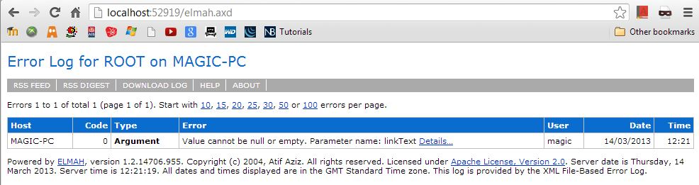

## Related Progress

### Mobile Site

Mobile views of the site have been created for all views in the application. CSS is yet to be implemented for these views and only basic functionality exists here for the time being

### Hidden Options

Functionality for logged in users has been separated based on table states (submitted forms or uncommitted user tables.). Options to enter the user view for data entry and the export option are hidden from the user until the table is present (submitted) in the SQL database.

Once the table has been submitted as a form to the SQL database, the option to edit the table is no longer available; the table must be dropped and recreated for any changes to be made.

### CSS

Changes to the layout and CSS of the website from the default template have begun to take place. We see this as an ongoing process and one which will be concentrated on more so in the later iterations of the project.

## Class Diagram



## Database Schema

#### Entity Framework



#### SMO Database



## Macintosh HD:Users:shanemurphy:Desktop:Screen Shot 2013-03-14 at 12.41.11.pngRevised Release Plan

## Difficulties and Learning Outcomes

### Story ID: 4 - Table Exports

Some time spent seeking a code solution to separating .CSV file values into separate columns in MS Excel. Ultimately turned out to be a problem with settings in the Excel application itself.

### Story ID: 8 - Mobile Forms

Our main focus when dealing with mobile forms was dealing with user input into the system, and protecting our application from malicious or bad input. The Razor engine implemented in MVC4 automatically protects against cross site scripting (XSS) by rendering all input collected using the razor ‘@’ tag as plain text.

Cross site request forgery attacks (CSRF) can be protected against using the Html.AntiForgeryToke() method. This method issues a random token to the user to protect against this; however, it requires the use of cookies. We have not implemented this as yet, but may do so in a future iteration.

### Validation

We are using The Data Annotations Extensions package available from the NuGet installer to validate certain user inputs, e.g. the Email field required for registration. Other user input is validated using JQuery Validation. A number of different examples and methods are recommended online, leading to much time spent experimenting and trying out a number of different approaches.

### Story ID: 7 – Public URLs

In order to generate a custom URL such as localhost/magic/5, we needed to create a separate method to accept a username and retrieve the corresponding userId before passing to our original method. The problem with this is that as the user is not logged in, the SimpleMembership database has not been initialized at this point and we could not gain access to the database of users to find the UserId. We used the InitialiseSimpleMembershipAttribute(), which is a type of singleton design pattern to ensure only one instance of this connection is made.

We were unable to create a route such that the user could access the input for the tables through an URL similar to localhost/magic/5, the routing table seems to require some (any) values separated by a ‘/’ to replace as the specified default controller and action.

We settled to leave routing to localhost/public/form/username}/{tableId} for this iteration, allowing the user to access forms through localhost/public/form/shane/5 for example. We may return to this at a later iteration, but are content with results for now.

## State diagram



## Interaction diagram



# Iteration 3

## Implemented User Stories

### Story ID: 11 - OAuth

User can log in using an existing Facebook/Google account. There are no limitations in app functionality if the user logs in this way. When logging in for the first time, the user will be asked to provide a user name, which is set by default to the users full name taken from the third party. The application is configured to enable log ins using Twitter, but the twitter OAuth API requires that they be provided with a live accessible URL before this will function correctly.

### Story ID: 12 – Configure LAN Server

The application is now configured to run locally on any machine and allow incoming connections to access the application using the local hosts IP address. This allows us to test the application across multiple operating systems. We have discovered issues with the CSS through this type of testing.

## Related Progress

### CSS

The default ASP.NET MVC style has been modified to better reflect main purpose of the application. The new CSS is skeuomorphic in nature. The layout is designed to resemble a notepad lying on a desktop table. The text on the site is styled to be reminiscent of handwritten notes. We used a mnemonic approach to some icons on the site, in particular, form actions (edit/delete/export). We hope these icons improve the usability for the user, and will implement tooltips to avoid any possible confusion.

An image slider powered by JavaScript (taken from [Menu Cool](http://www.menucool.com/javascript-image-slider)) has been added to the Home page, this will eventually house images that give the user an overview of the applications functionality and how to use it.

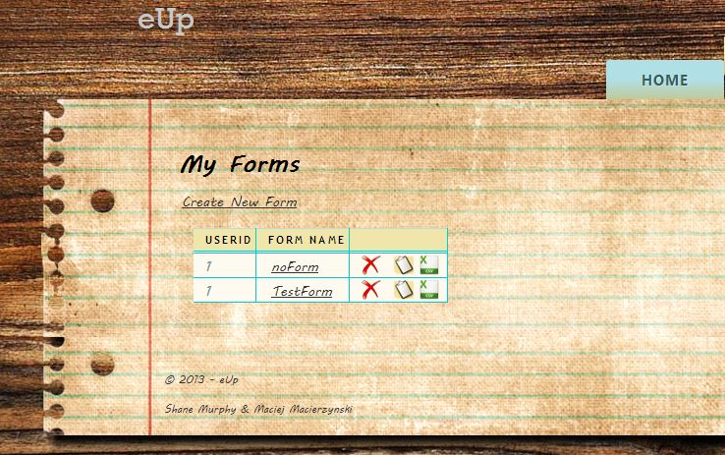

### Mobile Access / View Switcher

User accessing the application from a mobile device will be presented with a mobile version of user interface. For this purpose we have chosen to use a JQuery Mobile framework. JQuery provides good integration with ASP.NET MVC and HTML5, which we plan to use later for local data storage. More mobile views are to be added in the next iteration to allow the mobile version to provide all the necessary functionality to work as a standalone application from the full web version.

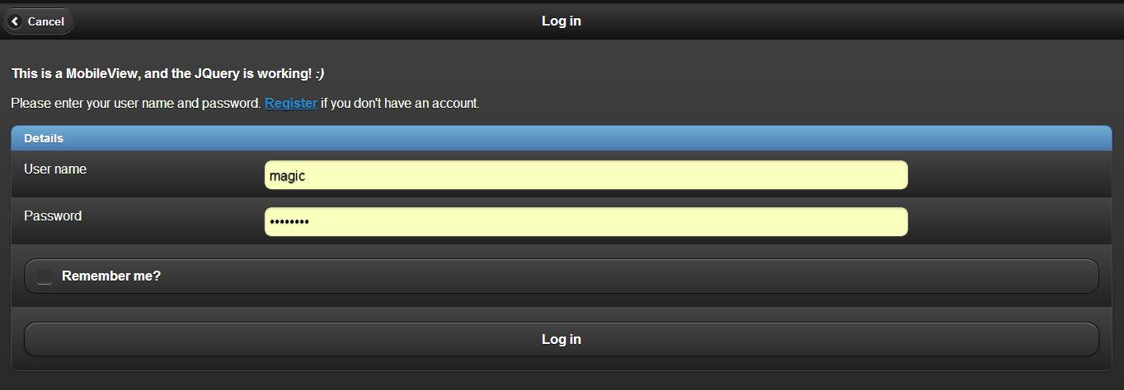

## Class Diagram



## Database Schema

### Entity Framework



### SMO Database



## Mountain Lion:Users:shanemurphy:Dropbox:3rdYearImagineCup:Submitions:Upload 4 - 5th April:Release Plan.pngRelease Plan

## Difficulties and Learning Outcomes

### Story ID: 11 - OAuth

Each service (Facebook/Google/Twitter) has a different way of generating an AppID and AppSecret values. Once we obtained these values, we could integrate them into our application code in AuthConfig configuration file.

### CSS

To accommodate the images inside the JavaScript image slider on the Home page, we decided to keep the website at a fixed width, which is always centred in the users browser.

The navigation tabs appear out of line on some operating systems and browsers, we are working to fix this in the next iteration.

### Mobile View / View Switcher

Some time was spent troubleshooting the mobile views and CSS. As the JQuery within the views was not being loaded within the mobile view. The cause of this turned out to be a JQuery Mobile package version. After reinstating a previous version of the package, the problem was resolved.

## State diagram



## Interaction diagram



# Iteration 5

## Implemented User Stories

### Story ID: 9 - Statistics

Statistics can be generated on a form-by-form basis for any numeric fields. The minimum, maximum and average data are presented to the user visually using a bar chart. Statistics are also presented for any Boolean fields (Yes/No), and displayed on the statistics page for that particular form.

## Related Progress

### Payment

PayPal payment integration was attempted on this iteration, but proved to be more complicated than expected to integrate in an acceptable way within the application. The decision was made to postpone payment implementation for the time being and possibly indefinately as it is not a core function of the application and we felt our time could be better spent elsewhere before the final release is due.

### CSS

Issues with the out of line navigation bar have been resolved and the navigation bar is now inline.

### Mobile Views

Additional mobile views have been added to increase functionality to mobile users. Users can now log in and access their forms and form data. Some functionality of the full web service is not included in the mobile application, such as the ability to edit or view form data on a mobile device. We expect mobile users to be mostly interested in filling data into existing forms. The view switcher at the top of the page will allow mobile users to access the full web page if full functionality is essential in a mobile environment.

## Class Diagram



## Database Schema

### Entity Framework



### SMO Database



# Release Plan

## Difficulties and Learning Outcomes

### Story ID: 10 - Payment

Integrating PayPal into our application proved more challenging than initially expected. We believe the time cost of implementing a solution for this is greater than the benefit of the extra functionality. As such we have postponed implementing a payment system indefinitely due to time restraints.

### Admin Access

Difficulties in adding a single Admin user to our database arose and we could not implement an administrator role in time for this iteration deadline. This will be implemented in the next iteration.

### Azure Access

Access to the 3 month free trial with Microsoft’s Azure service requires a credit card to register. Neither member of the team has a credit card to use in the registration. An email has been sent to the college to request a solution to this.

## State diagram



## Interaction diagram



# Iteration 6

## Implemented User Stories

### Story ID: 13 - Configure WAN Server (Azure)

The project is available at <http://eup.cloudapp.net>, however full functionality was not achieved. The webpage is fully viewable and the user may log in, however access to the forms tab is not possible and shows an error. This is because both the SQL database and a portion of the entity framework database has not been created on the server. We made many attempts to correct this problem, including changing the local encryption type to match azures, changing the connection strings and manually creating the databases on azures server.

## Related Progress

### Public URLs

When a form is submitted, a new field is now visable showing the public URL of the form, which can be used to directly access the Fill view for this form. Users can copy and paste this link into emails and social networking groups. It may also be promoted at events to allow users to use their own device to register rather than using the organisations own provided device, which may be in popular demand.

### CSS

Some small changes to the CSS of the wbsite have been made.

### Mobile Views

The ability to log off from a mobile view has been added. Each form in the view has 3 different links associated with it. Clicking on the Form name itself displays the data which has been entered into that table, clicking the word Statistics displays the mobile statistics page and clicking the arrow the the right displays the Fill table mobile view.

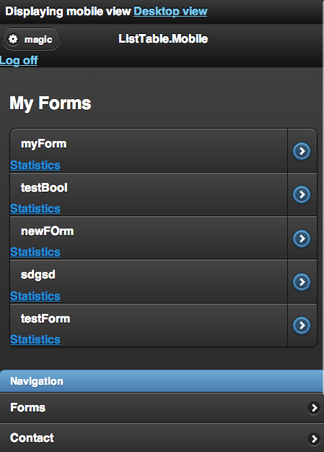

Additional mobile views have been added to increase functionality to mobile users. Users can now Fill in the forms within a movile environment.

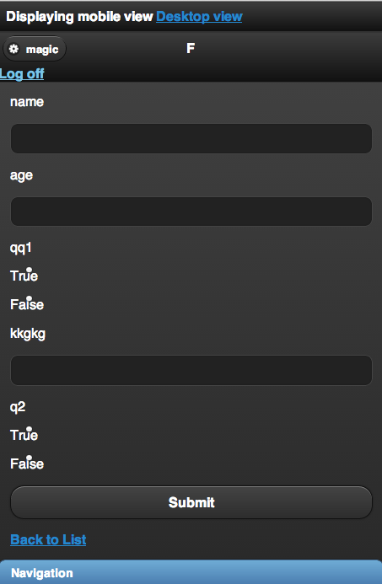

Statistics are now also available via a mobile device.

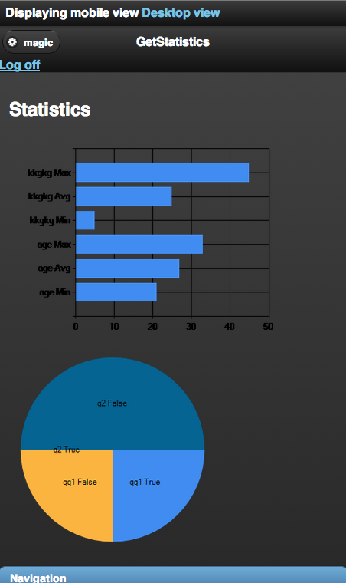

# Release PlanMacintosh HD:Users:shanemurphy:Desktop:Screen Shot 2013-04-30 at 10.59.27.png

## Difficulties and Learning Outcomes

### Story ID: 9 - Statistics

Problems with displaying Boolean statistical pie charts presented themselves. The cause of this was not applying a unique attribute to the boolean fields within the for loop to display them and as such, the system was reading all boolean fields as a single field and crashing.

Later, boolean statistics stopped working again. We discovered that we should not assign column names to variables in order to display them in a chart, but the preferred option is to have these names hard coded in the application. As our application dynamically generates these statistics across many different user defined columns varying by the user, it is not possible to implement such a solution.

### Azure Access

We were unable to enable full functionality on the Azure hosted server. The UserTable and Field table in our entity framework database were not carried across to the Azure database schema. We tried to create these tables manually along with a number of other solutions we came across online, but were unable to provide full functionality. The Azure site can only allow the user to log in, but any further functionality is unavailable. This may be accessed at <http://eup.cloudapp.net>

User Manual

**Design and Development Team**

*Shane Murphy: X00085315*

*System Design, Software and Database Development, System Testing & Quality Control.*

*Maciej Macierzynski: X00086366*

*System Design, Software and Database Development, System Testing & Quality Control.*

**About This Software Package**

This project aims to provide a simple, eloquent solution to sign up events data collection bottlenecks. Inspiration for this project came from first hand experience with college society and job fair sign up processes where applicants are predominantly required to sign up using pen and paper.

By making a service available to these organizations and societies, whereby they can create their own customizable e-forms to capture data specific to that organizations needs, store it and export it later, we can reduce time spent capturing data and processing paper forms into a database or email client later.

**Register**

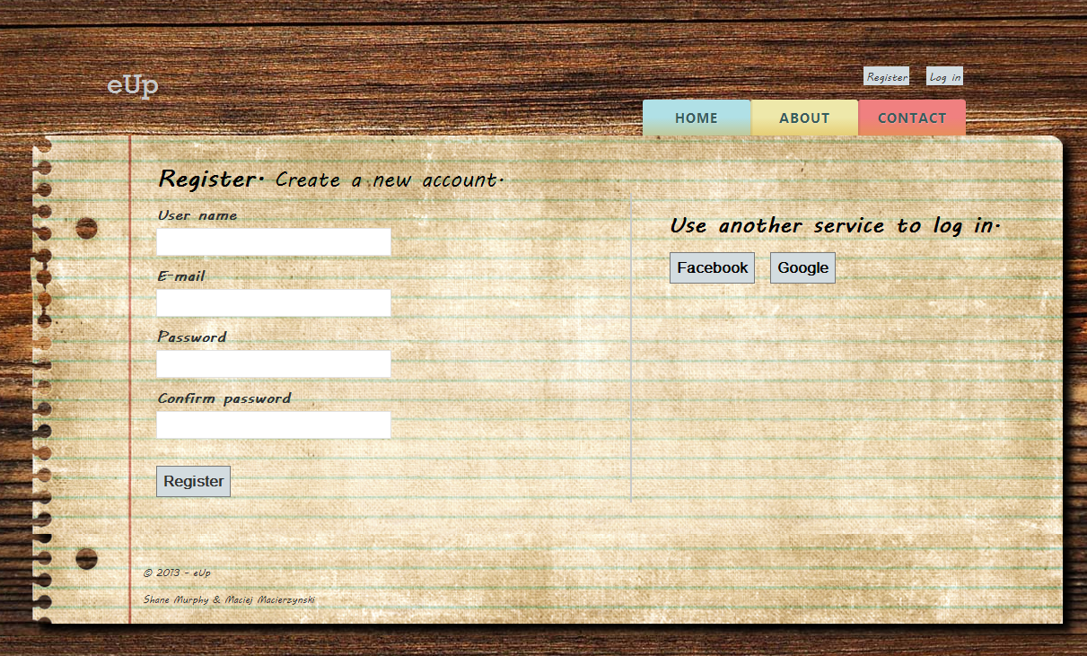

Users are required to provide a unique username, valid E-mail address and password when registering for the eUp service. Usernames must not already be in use by another user, Passwords must have at least 1 capital letter, a number or special character and be at least 7 letters long, and no longer than 16 characters. Passwords are to be entered twice to ensure no typing errors occur.

These conditions are validated and checked by the application, the following error messages are displayed to the user where appropriate.

**Registration Errors**

**Password Validation**

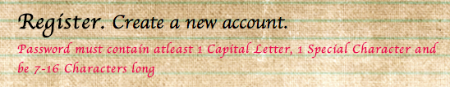

**Unique Username**

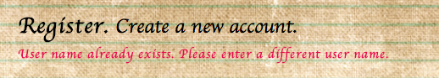

**Email Validation**



**Passwords Do Not Match**

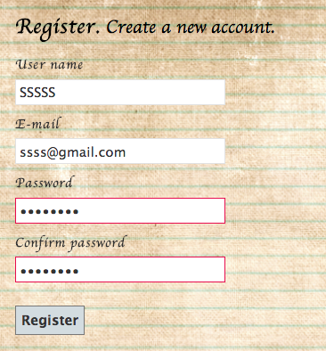

**OAuth**

Users may choose to forego creating an account and create an account via their preferred social networking site. The user must grant access to their basic data in order to proceed with this login method. Once appropriate permissions are received, the user must choose a username to associate themself with in the eUp application.

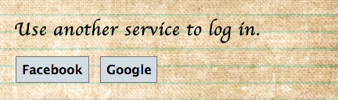

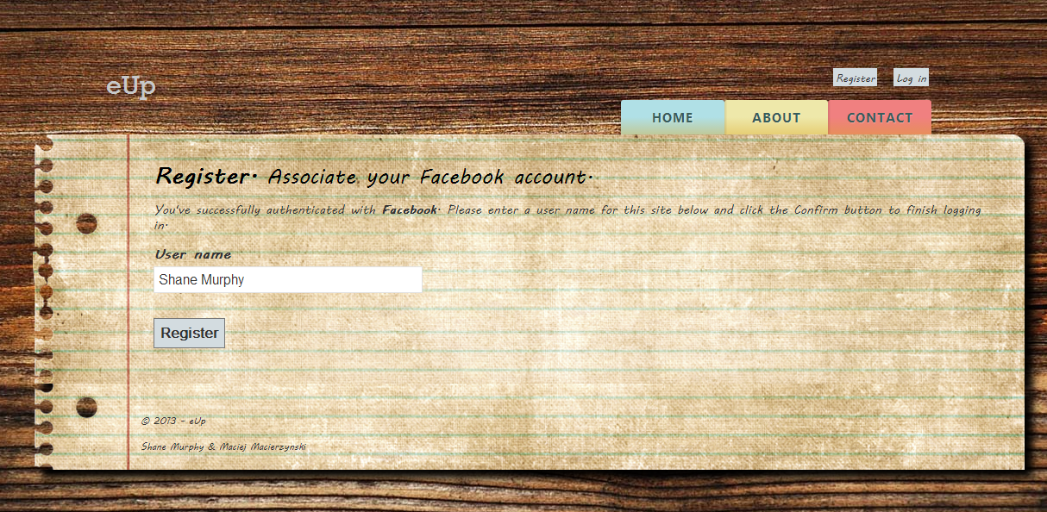

**Log In**

The user is required to enter their existing username and associated password in order to gain access to their user account and forms. A user will not be able to log in without first having registered. The user is validated and granted access to their account or one of the following errors is displayed to the user.

**Login Errors**

Incorrect Username or Password

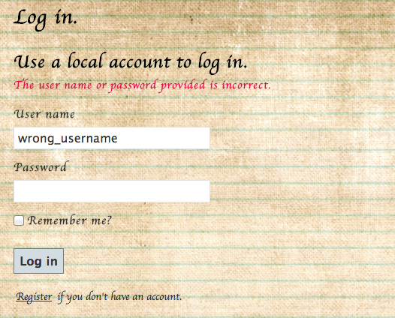

No details Entered

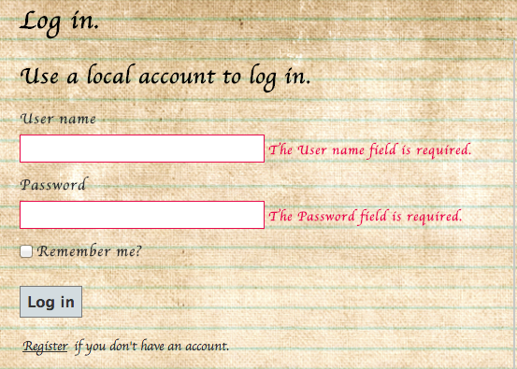

**Manage Account**

Once a user has logged in, they may manage their account by click on their username at the top right hand corner of the screen. A page will be displayed allowing users to change their password and connect to their login to their social media accounts.

The user may not change their password without first entering the correct current password.

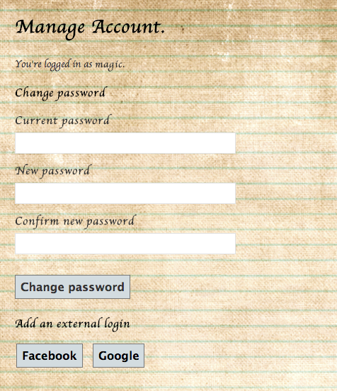

**Manage Account Errors**

**Incorrect Current Password**



**Forms**

**View All**

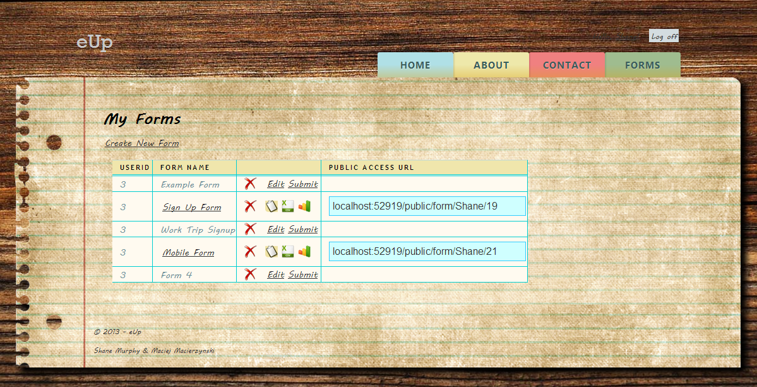

Clicking the Forms tab on the page brings the user directly to an overview of their current forms associated with their account. From here the user can choose to Delete, Edit or Submit any forms that haven’t been submitted already, or Delete, Submit, Export or view statistics of any submitted forms. All submitted forms have a public URL that can be used to directly access the Fill Form page for each individual form. Users may also choose to create a new form.

**Create**

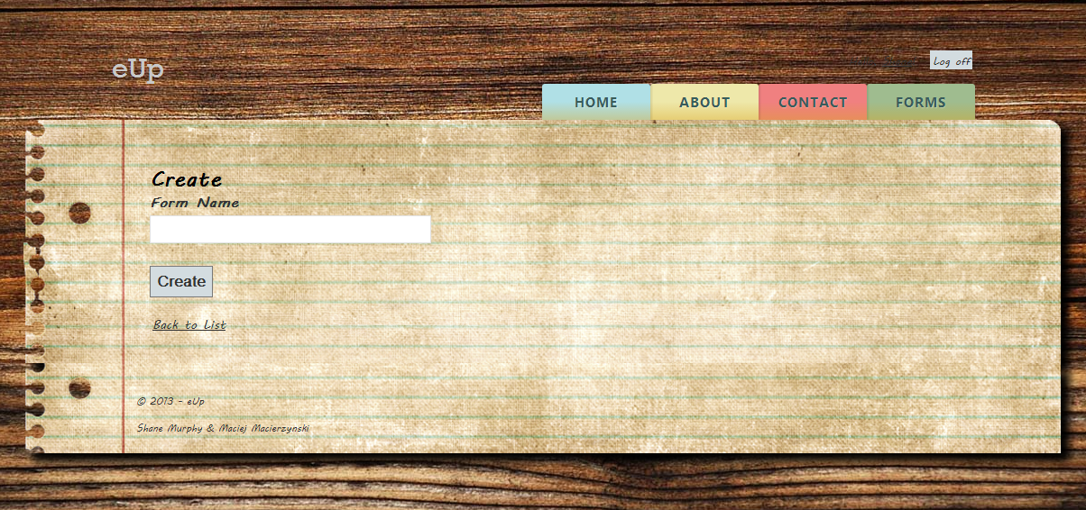

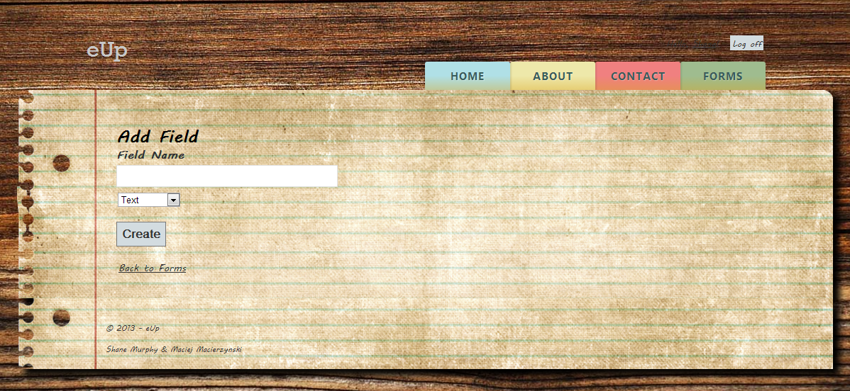

To create a form a user must specify a form name; once this has been supplied the user will be asked to name their form fields, which will later be submitted as column names in their custom table. As the user enters each field name, they are requested to select whether each field is one of 3 types, Text, Numeric or Boolean. This selection aids in input validation when data is being entered into he form and also allows for statistics to be generated from this input.

**Edit**

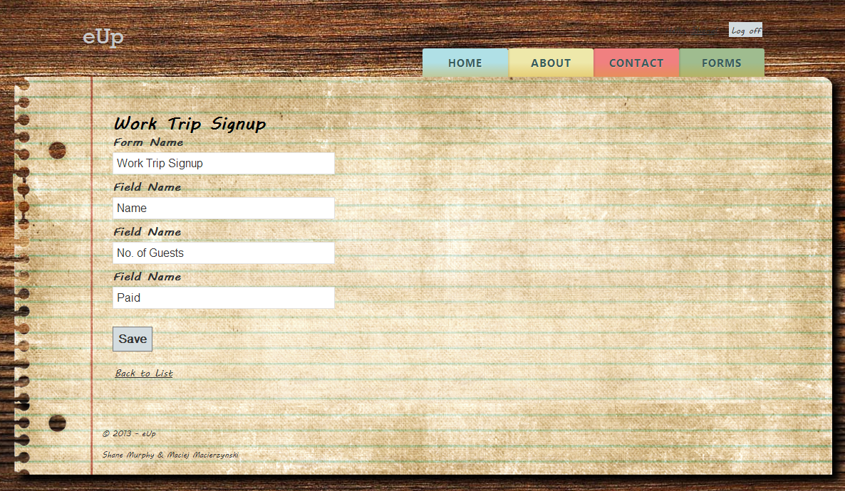

The Edit option allows users to edit the details of their already created, but unsubmitted forms. This includes changing the Form name, and all Field names within the form.

**Delete **

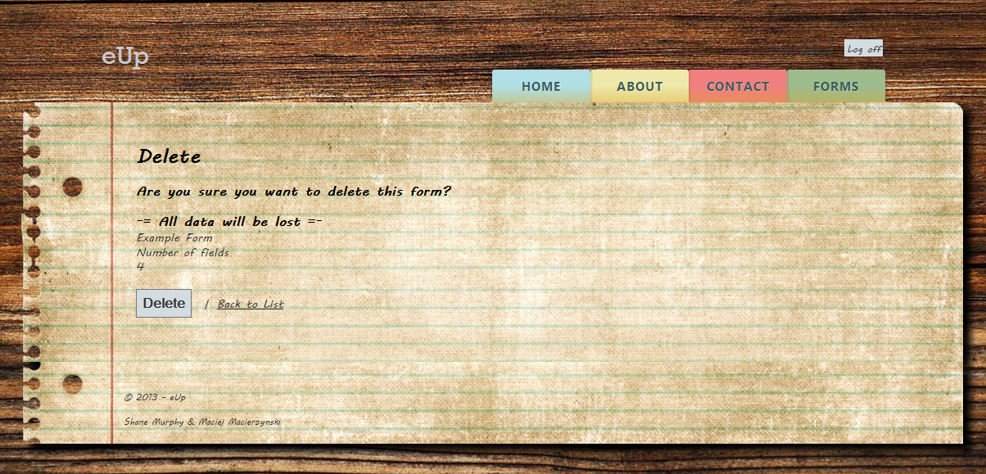

Any form, whether it is submitted to the SQL database or not can be deleted. This is a permanent action that cannot be recovered from; the user is warned of this and asked to confirm the request to delete the table. If the table has been submitted and data entered into the table, all data will be lost upon deletion. It is recommended the table be exported before deleting permanently.

**Submit**

The form must be submitted to the system before any data can be captured. By submitting the form, you lose the ability to edit the form in any way. Once submitted, the options to edit or submit are replaced with icons allowing you to enter data into the table, export as CSV or view statistics relating to the table, if data exists in the table.

**Fill **

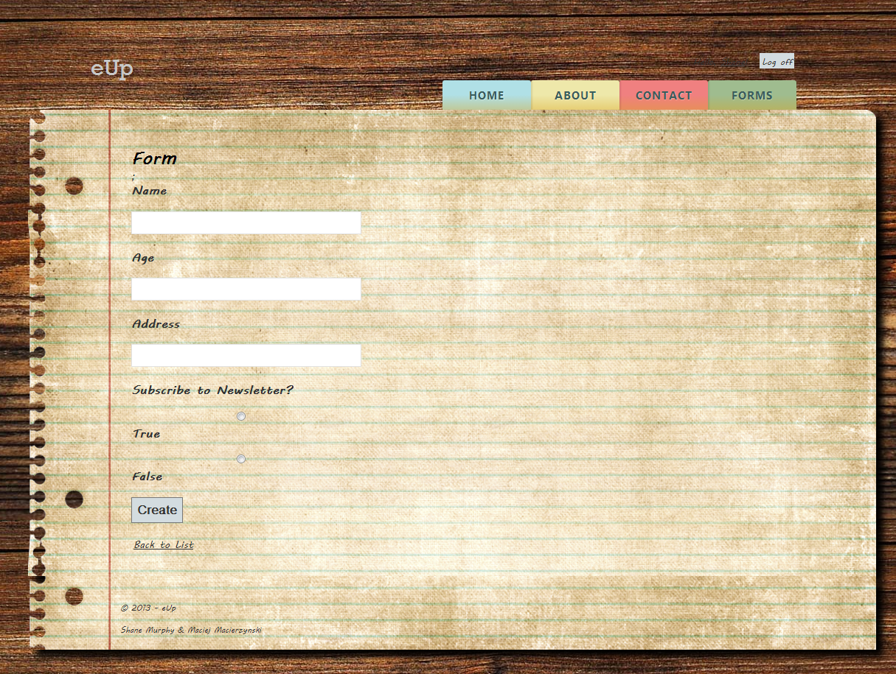

Each form is presented differently to the user when the Fill view is called. It displays each form field in the order they were submitted to the system. The field type selected earlier is used here to validate user input, depending on the field type. Boolean types are displayed as two radio buttons.

***Text Validation***



***Numeric Validation***

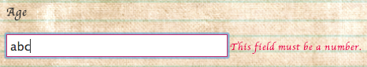

**Form Data**

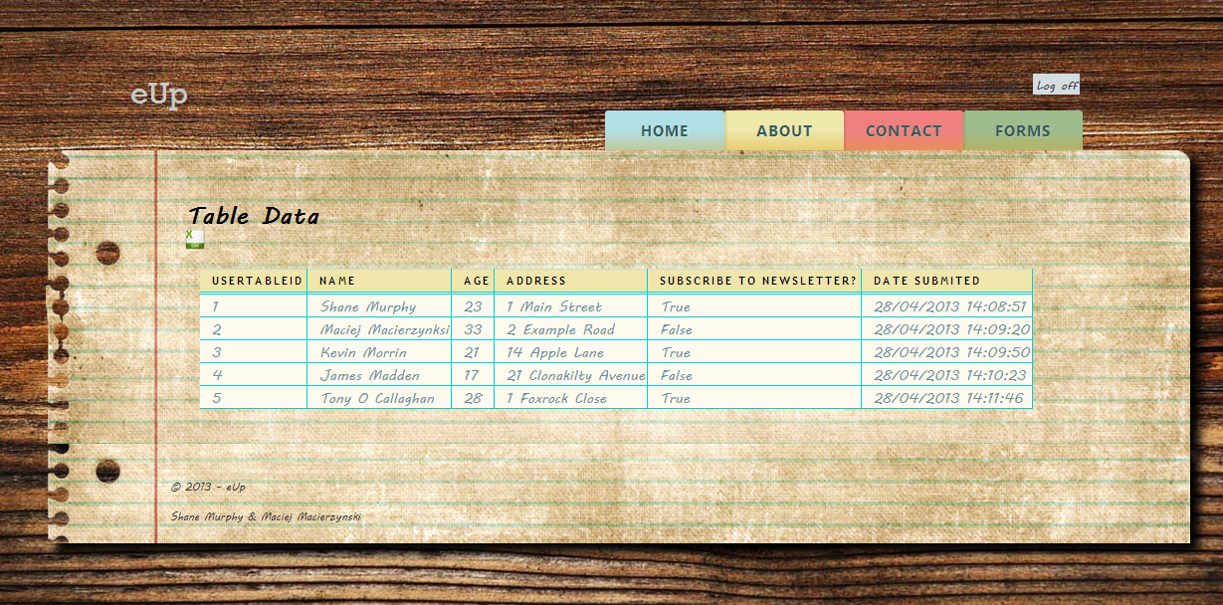

By clicking the required form name, the user may manually view all data submitted to the form to date. The user may also export the form as a CSV file directly from this page.

**Statistics **

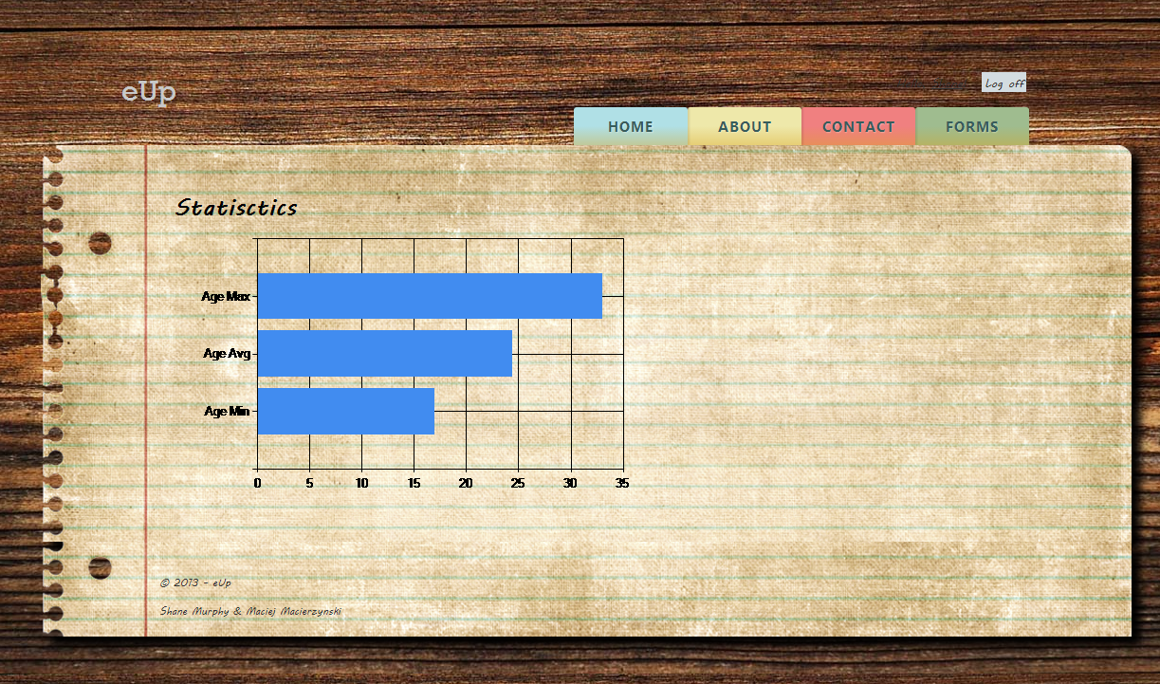

Statistics are generated for all numeric and Boolean form fields in a table. This data is real-time and can be accessed as long as there is values stored in the form.

**Export **

By clicking on the CSV icon beside the form name, or within the table data view, the user can download a .csv file of the table to their local machine.

**Mobile Views**

All major functionality is available from mobile devices in a more mobile friendly layout. All functionality works as specified for the main view unless otherwise specified.

**Login**

Users can login to the service from a mobile device just as they would from a full desktop web browser.

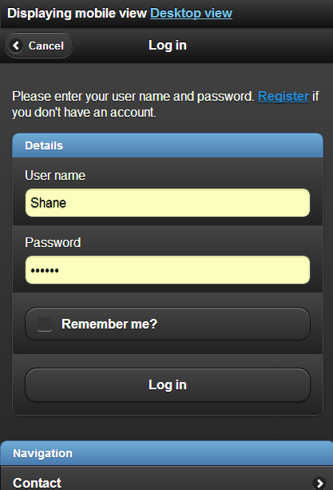

**ListTable**

Once Logged in, users will have access to their associated forms. They may access the form data by clicking the form name or larger square of the select button, or view statistics by clicking the word ‘Statistics’. Clicking the arrow to the right will bring the user to a mobile view where they can collect form data.



**FillTable**

Users can fill the table with data from a mobile view.



**Statistics**

Users can view real-time statistics from their mobile device.



**Form Data**

Users can view all form data currently in the table from their mobile device.

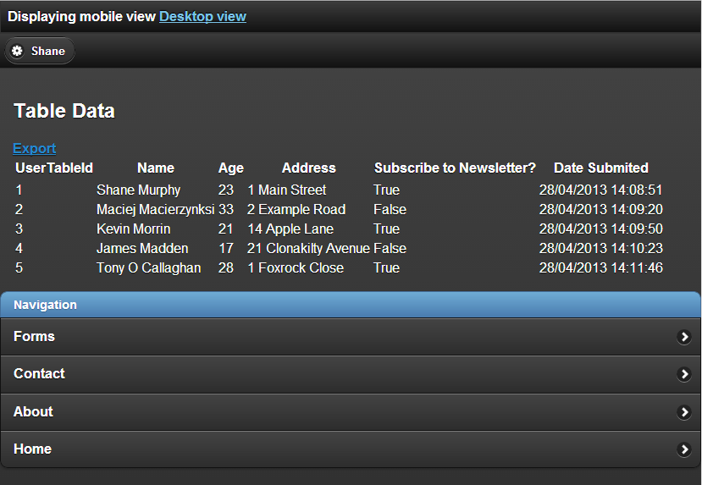

**Create Form**

Users may not create a new form from a mobile device; this must be done in a full desktop browser. The option to switch to a desktop view is available in the event that this functionality is required away from a desktop machine.